 | Personalized Healthcare Innovations  Symposium  Tuesday, October 23rd |  |  | Thank you Sponsor  
  Change Agent |  | PROGRAM | Chateau Louis Conference Centre  
Health services are rapidly maturing as technology, innovation and enterprise focus on personalizing service. ABCtech is offering you a glimpse of how innovators are responding to increased demand for personalized healthcare. Expectations are sure to be exceeded: learn, network, and decide – is this the future you have been waiting for?
3:00 – 4:30 Workshops – simultaneous
#1. Vermillion Room  DATA. Enterprise Software. Core Data Models.  Rene Kohut & Blair Kjenner – Method 1 Software | 
Data is an essential asset in health care and systems are routinely developed for improving and personalizing services. BUT the systems are often incompatible, generating islands of data, frustration and waste! A frank, insightful workshop on how should systems should be integrated and developed in the future, for leapfrog SAP, PeopleSoft, Oracle, Microsoft ERP systems.
#2 Roslyn Room  FINANCE. Financially Preparing for Investors and Taxes.  Lynn Gagne-Webb – Entrepreneurial Intelligence | 
An accounting and financial workshop for learning about small business financial needs and obligations for both investors and the Canada Revenue Agency. Learn the basic MUSTs and SHOULDs for your financials/bookkeeping, how to avoid the top 5 mistakes of entrepreneurs that cost a lot of money, the type of accounting and financials that prospective investors will want to see. And more….

#3 Roseberry Room  DIAGNOSTICS. Personalized Diagnostics Panel  Chair – Alexander Suen, Alberta Council of Technologies  - Bo Cao, Dept of Psychiatry & AMII - University of Alberta  - Justin Reimer, Sr. Provincial Director of Innovation Partnerships, AHS  - Jason Pincock, CEO, DynaLIFE  - Christopher McCabe, CEO, Institute of Health Economics  - Colin Coros, CCO, Nanostics  - David Chang, CEO, Metabolomics Technologies | 
Discussing the development of personalized diagnostic technologies for serving the increasing demand for personalized health care featuring: Alberta Health’s Transitional Lab Space, Institute of Health Economics, Dynalife’s Diagnostics Incubator, Nanostics Dx, and Alberta Machine Intelligence Institute.

4:30 – 6:00 Reception – Cash bar.
Sponsored by BioAlberta - Rob Stoddard introduces Reg Joseph – CEO, Health City and Patty Wickson, Exective Director, Alberta Health Services - Health Innovation Management.  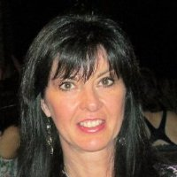  Reg Joseph Patty Wickson | 

6:00 – 7:00 Buffet Dinner – Commercial and Vermillion Rooms

7:30 – 8:30 RISING STARS introduced – brief presentations
Private enterprises selected as Regional innovations with global reach and contributing to the personalization of health care:


Randy Duguay
Founder of Health Gauge – more than simply a wearable device. It is a complete personal health monitoring solution: interactive, generating insightful personal health data by innovating in the fields of artificial intelligence, machine learning, data tagging, signal processing, and internet of things. Used regularly, it is a pathway to understanding, monitoring, and personal health.


John Lewis
Nanostics focuses on the development and commercialization of novel and non-invasive diagnostic tests to help manage disease. Our lead product, Clarity DX Prostate, is the most accurate test to diagnose aggressive prostate cancer. Clinical validation studies are underway on Alberta patients in partnership with DynaLIFE. Clarity DX Prostate is expected to be on the market as early as 2019.


David Chang
Specializing in metabolomics-based diagnostics for the healthcare market. Focused on driving novel research findings to commercial products, MTI received the 2014 North American Frost & Sullivan award for Technology Innovation Leadership.


D arryl Humphrey



People are demanding accessibility, choice, and an efficient way to interact with the health system. Trioova offers in-home, on-site and telehealth services. Online and with the mobile app, clients can securely interact directly with healthcare professionals. Messaging and sharing personal documents and managing their appointments and payments.

8:30 THANK YOU! and Networking continues …
EVALUATION

Did we meet your expectations? Yes [ ] No [ ] Sorta [ ]

Comments. _____________________________________________________________

ABOUT ABCTECH
 | Annual Membership w/benefits  General $100 Student/Senior $25  Visit ABCtech.ca
We are a non-profit Society founded in 2005 advocating for the diversification of Alberta’s New Economy through the commercialization of emerging technologies. Our community is comprised of over 21,000 people who we rely on as volunteers and for sharing their BIG ideas and viewpoints, challenges and opportunities.
If you have enjoyed today’s Symposium become a Member contributing to the New Alberta! Contact pkinkaide@ABCtech.ca or visit ABCtech.ca We are also seeking patrons and project sponsors.
Our events and projects are conducting in collaboration with other technology industry NGOs – non-government organizations, belonging to our Technology Industry Alliance  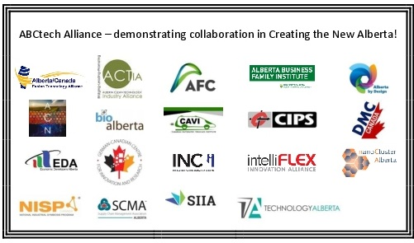 | All initiatives are administered 100% by volunteers and supported on a project by project basis - 2018:  Consultation: Engaging Youth – the future of work … Local (2017). Alberta (2018), National (2019), and Global (2020).  Commissioned: the TechInvest investment fund and the Ontario Council of Technologies Society.  Co-hosted: Creating the Western Canada Hemp Industry Conference and Moonlight in the Meadows – all-industry networking BBQ.  Research: Is public Procurement Broken? and our semi-annual assessment of Alberta’s economic resilience and effectiveness of it’s innovation ecosystem.  All are available at ABCtech.ca

