**WHIMSY – Moments and Memories**

In time we touched; life and love will never be the same



By Perry Kinkaide

Known otherwise as “Panda”

**Foreword**

Many of our southern neighbours see us Canadians as hunkered down throughout the year in igloos with but a brief reprieve in mid-July. They call it winter; we call it long -  a season unfamiliar to most in the south.

Those in the south are frequently reminded of our plight by US weathermen who refer to cold fronts from the north as "Alberta clippers". The blaming serves to reinforce deeply held views that Canada is uninhabitable.

Now I should explain why I'm keen to perpetuate this aspect of fake news. I like - in fact, I love it. Being "uninhabitable" helps us preserve our independence and our unique culture. And it is a helluva lot cheaper than borderwalls, forts, or a military. The weather while trite is an effective defense and really affordable. Cold carries with it a sense of something to be avoided. And it works.

US - Canada immigration is remarkably one way and usually weather related. Canada geese similar to our migratory snowbirds convey a consistent message that Canada is "uninhabitable".

Canadians when travelling south are asked "Just how bad is it?", "Why did you immigrate?", "Should I bring my skis?", "Do you have roads, power, outhouses?"

Their real surprise is to find that Canadians are a warm people with an infectious imagination born out of those long, dark - otherwise, dreary nights.

My view is that all Canadians should do their part in conveying that Canada is cold and uninhabitable. This guidebook is my contribution: an assembly of stories and games that parents and grandparents can use for whiling away the winter and entertaining their children and grandchildren.

All my offerings are guaranteed to work - tested and certified.

But first a little about me, the author. I am a contrarian - having immigrated north from a little country village on the Long Island shore  half a century ago. I am blessed with two grandchildren: Sofia and Cohen. The later of course is named after Leonard. To them, I am "Panda" - chosen when the family gathered to allocate those grand names.

As for my two children, Peter and Paul, our trio - Peter, Paul and Perry, remains unrealized. My wife, Sasha is also an immigrant - and a romantic, from Prague. She is also a child psychologist. We all value learning - but even more, we value whimsy. Moments and memories.

The assembly of moments have survived the years as our very best recipes for fueling a child's imagination.

* Perry Kinkaide, November 11, 2018

**1. BUNNY HUNTING**

Bunnies are cute and energetic, soft and furry. And they lay colorful eggs. If you want an ongoing supply, you need to lure them. The best time is after a snowfall, so anytime before or after July. Here is how.

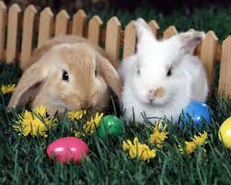

Depending on how many children are in your hunting party you'll need a few big carrots and some strong string. Tie each carrot to a line of string. The lines should be long enough so bunnies can't see or smell that you are nearby. Then ...

Prepare - Dress warm. Most hunts last a few hours so you may need to pack a snack. I suggest keeping the snack in a pillow case. You can use it for bringing your catch home. You are now ready.

Where to hunt? There are many places where bunnies live - a nearby woods is best. But if they are very brave, they can also be found in backyards particularly around Easter time. Best way to tell is to look for bunny footprints. But don't confuse them with prints of your neighborhood sled dogs.

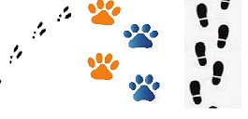

There are many proven hunting methods. But this one is best for small parties or if you hunt alone - trolling.

Trolling. Walk slowly through your hunting grounds dragging the carrot behind you. The string should always be straight behind you, turns can be tricky. Your neighbourhood sidewalk is a good option before it is shoveled.

The dragged carrot will leave a straight line-trail and a carrot-scent in the snow. Don't walk too slowly or too fast or the bunnies will not come to you. Keep your looking for other line-trails. If you spot one, you'll know there are other hunters around. This is a good sign.

Caution. If the snow is deep, the carrots may get stuck in your footprint. You'll feel a little tug. The tug may fool you into thinking you have a bite. So watch the carrot carefully.

Jigging. If trolling doesn't work then try jiggng - short and rapid tugs. This helps the bunnies see the carrot better. Jigging is also a way to get your carrot out of a footprint.

Bobbing. I've tried this too, but most bunny hunters find this way too boring. Find a bunny trail and push some snow into a pile on the trail. Then stick the carrot, bottom down into the snow, and hide behind a bush or nearby tree and wait.

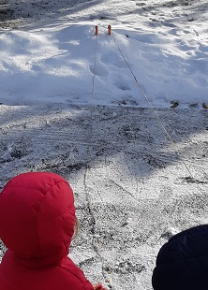

Be very quiet. Neighbors like this. Bunnies have big ears so they can hear you really well. They also have a wiggly nose made especially for smelling carrots and night vision from eating carrots.

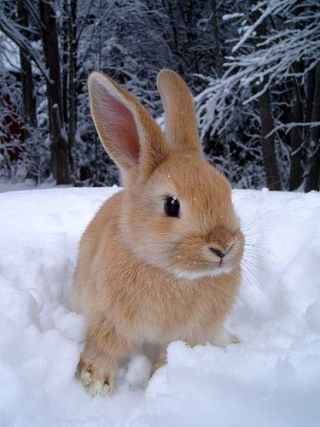

Sometimes strangers may wander by. Offer them a snack if they want to stick around.

Give up? Don't expect too much too early. If you get cold or it's time for supper, then consider this. You want bunnies to know that you want to be their friend. So I suggest you tie the carrot line to a tree or bush or nearby fence and leave it overnight. The next day you can check for nibbles or to see if the carrot is gone. If you are really lucky, a bunny may even be waiting. Good hunting.

Sofia didn't have any luck.

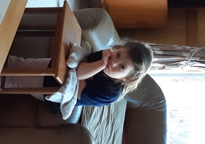

**2. BATH TIME**

Yes, we have indoor plumbing. This moment is best just as kids are learning to count.

Once their bath is over and it's time for drying, ask "Did you clean your ears?" Regardless, do a check and put up two fingers opposite his/ her ears and look through his/ her ear from the other side. Be sure to get the number of fingers right and declare, "Clean! I see two fingers." Smiles all around.

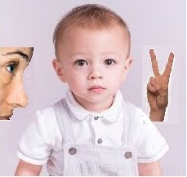

You'll be amazed this will work for years and be fun to recall forever. Caution though, once the secret is out you may find your relationship with your children changes. Note. There is nothing magical about two fingers. Other numbers up to five also work.

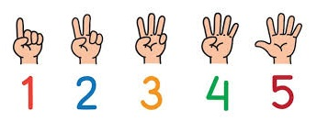

**3. GARDENING - Spaghetti bush**

Games in the garden can be very educational and entertaining. These games worked well for my boys but did result in a call from my the school. The teacher was incredulous.

Our garden is well know by the kids for having a spaghetti bush. Just about any bush in the fall or early spring will work. When it isn't producing spaghetti, it may call for more fertilizer. Ketchup mixed with hose water in a watering can may do the trick.

Harvest Time Winter Time

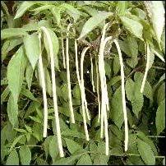 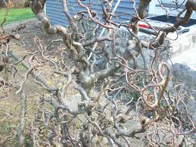

**4. GARDENING – Popsicles**

This is a winter project. All you need are popsicle sticks and a garden site. Talk up beforehand the wonderful yield of popsicles you grew when you were a child. Then ask if they'd like to learn.

Give your child a few popsicle sticks and go out to the garden and poke them each into the snow in a nice neat row. Best is to plant each stick about 6-inches apart. Stress the importance of the distance.

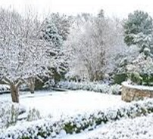

Overnight while the kids are in dreamland, slip out into the garden...carefully stepping into your earlier footprints! This is very important for older children. Then replace the popsicle sticks with real popsicles.



In the morning make a big deal of "Harvest time!" Their teacher will be amazed of their contribution at their next "Show and Tell".

**5. MARRIAGE**

Kids do say the funniest thing, and they can be very observant. For some exercises I recommend heartily that you just sit back and listen. "Family" is an important concept and easily grasped. Love too is easy as are mom and dad.

But marriage, well in a classical sense children get the jist of it, mom and dad together. But ask do you ever want to get married? And why? The answer can be startling.

Cohen's wisdom...age 3. Ans. "Because I want the experience."

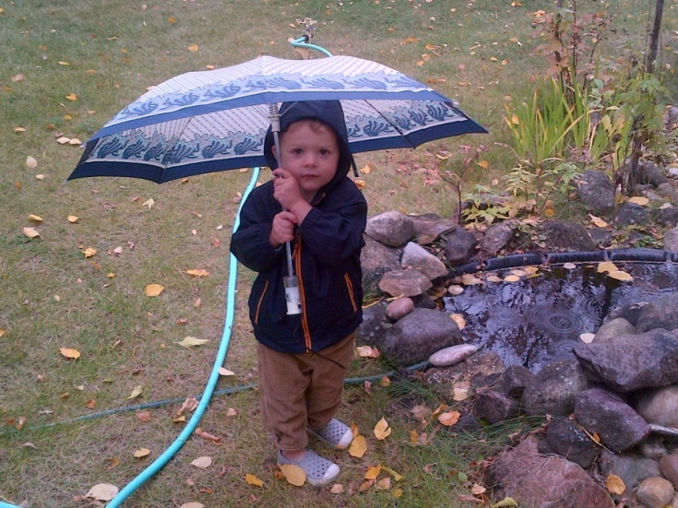

The question "What do you want to be when you grow up?" is sure to yield insight. Cohen's future  focus was a surprise. "I'm not going to work. My wife will." He continued, "I'll drive nana to work each day, in her yellow, convertible Camaro."

**6. CONSEQUENCES**

From time to time the whimsy takes on a more serious and concrete form. Just when you think you've learned to teach dancing on a cloud, reality can kick in. Here is what I mean. I'll again share a personal experience.

We - including the grandkids, were invited to a wedding. Before the ceremony, we had gathered together as a family for breakfast at the hotel buffet.



The setting was somewhat chaotic, as many other families also with kids gathered. Children were scurrying about, seemingly everywhere. Cohen rarely got engaged, but this time the energy was infectious.



Instructions to "Settle down," were ignored. Then I was left alone as all - except Cohen and I, left to dress for the big event. My tolerance for chaos was to be tested. Finally, I called Cohen to task. "Sit down. Here. Now!" Ahh, it worked. And I continued, "If you don't settle down there will be consequences," I explained and not in a low voice. I recall being somewhat proud of my demeanor.



Then, then without blinking Cohen replied," Consequences. You want consequences. If YOU don't settle down, I will take the license plate off your car and YOU won't be able to go home."



Well that shut me up. I did not reply and would advise never to get in an argument you can't win.

**7. CATCHING BIRDS**

This is a family trick, one I learned from my dad. All you need is a trusting child and a salt shaker. When you want some private time send your curious child to the yard to capture a bird. Robins are easiest, crows the hardest.

Explain that all you need to do to capture a bird is to sprinkle a little salt on the bird's tail. But you must be very quiet.



Should they return frustrated, it is probably because they are moving too fast or making too much noise. So send them back urging patience or a different bird.

This game will last for only about 20-minutes. So if you want some privacy, be quick.

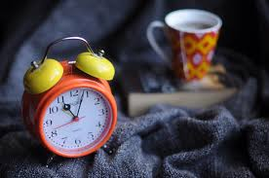

**8. WHEEL TIME**

We all I am sure value most of the time together with our kids and grandchildren. I know I do and in particular time in transit between the cottage and home. Consider some of the games. Witness some of our discussion.

*Where in the world do fire-breathing dragons live?*

I'm sure there are several woods, vacant buildings or suspicious sites you can muse over. Choosing and cultivating the reality is great fun. Adding to the excitement of tripping to the lake was passing by the cave of a fire-breathing dragan as it appears here. We were usually going a tas bit too fast to see the detail, but Cohen was sure he saw a dragan at the window several times.

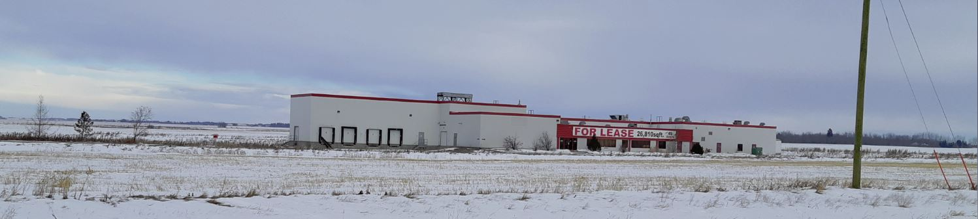

After one of the for-sure sightings, Cohen asked, "Panda, do fire-breathing dragons have bandaids on their lips?" I don’t recall my response, but do recall my smile and comfort that Cohen was my version of the Little Prince.

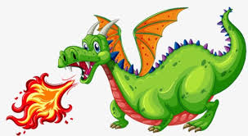

*Needing help making it up and over the hill.*

When confronted with a BIG hill, it's a thrill when no traffic is around to let the car coast slowly to about a stop and diagnose the problem with such proclamations as, "Uh oh! We are out of gas." Or, "This car is getting really old." Or even better, urge it on by turning on the windshield wipers and shouting "Accelerate!" Kids love this one, and soon learn to shout it themselves.

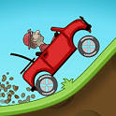

*There is always a sing-along*

|  |  |
| --- | --- |
| Splish, splash, I was takin' a bath Long about a Saturday night, yeah A rub dub, just relaxin' in the tub Thinkin' everythin' was alright  Well, I stepped out the tub I put my feet on the floor I wrapped the towel around me and I Opened the door  And then a-splish, splash I jumped back in the bath Well, how was I to know There was a party goin' on?  There was a-splishin' and a-splashin' Reelin' with the feelin' Movin' and a-groovin' Rockin' and a-rollin', yeah, yeah  Bing, bang, I saw the whole gang Dancin' on my living room rug, yeah Flip, flop, they was doin' the bop All the teens had their dancin' shoes on | There was lollipop with a Peggy Sue Good golly, Miss Molly was-a even there too A- well-a, splish, splash, I forgot about the bath I went and put my dancing shoes on  Yes, I was a-splishin' and a-splashin' I was a-rollin' and a-strollin' Yeah, I was a-movin' and a-groovin' We was a-reelin' with the feelin'  We was a-rollin' and a-strollin' Movin' with the groovin' Splish, splash, yeah  Splishin' and a-splashin' One time I was splishin' and a-splashin' Ooh, I was movin' and a-groovin' Yeah, I was splishin' and a-splashin'  Thank you Bobby Darin |

Of course there are many stories and songs to while away the time. The very best I’ve found is "Splish splash". I'm not sure why? Maybe it's the visuals or shear chaos, but of all the songs, it ranks highest in demand.

As for games, here are but a few: counting hay stacks, playing license plate poker, first to sight a pink convertible.

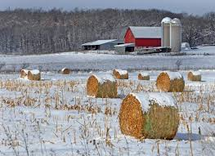

**9. GHOSTS AND THINGS**

This one needs to be executed with caution. It served to entertain and mesmerize us for years, a credit to my dad. "Harvey" was born to explain the noises coming from the ceiling or anywhere else in the house.

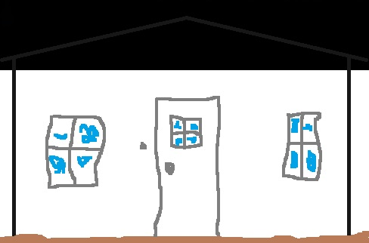

He - Harvey was a he, existed for years in our imagination as either a wee little mouse or a gargantuan creature holed up in the attic. He never died and would be recalled as a family member at each reunion right along with the family pets. Dad had a personal relationship and could tell yarns for years upon request about Harvey.

**10. SANTA**

I suspect most of you are familiar with Santa's appetite for cookies and a treat - usually a carrot or two, for his reindeer. Both were placed obviously in front of the fireplace. And other than a few crumbs most were always gone Christmas morning.



Sometimes there were even smudges of soot or a foot print on the rug.

**11. MOON TRAVEL**

Once the kids were old enough to attend to that big, round, shiny spot in the night sky, it was time to give it some character. Who lives there? How to get there? What is it made of? These are but some of the questions that can shape evening chats, enjoyed best flat on your back on a grassy knoll.



But be ready for the odd surprise. Cohen when asked how to get there shared to my surprise that a rocket was best. "Good for you", I thought. But when asked, what he would find on the moon when he got there, he piped up without hesitation, "A cow!" That insight prompted further discussion about a cat and a fiddle, and how high cows can really jump.

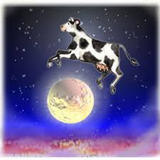

**12. LITTLE THINGS**

Lady bugs and ants can be the stuff of fairy tales. Tadpoles and frogs too. Where did the spots come from? Where do they live? Are they happy?

 

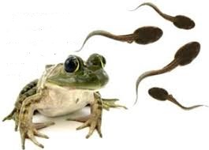

**12. BIG THINGS**

I need not tell you that dinosaurs have a special fascination. But here begins a conflict. They do not live today, right? Right! And they are so big as to be unbelievable. Yet we as adults buy in - rather than whimsy, we typically tell stories to convey the dinosaur as a reality. We share the awe, the size, the whenever and wherever. It is the sharing of something so unreal that bridges the whimsy. In doing so we are together.

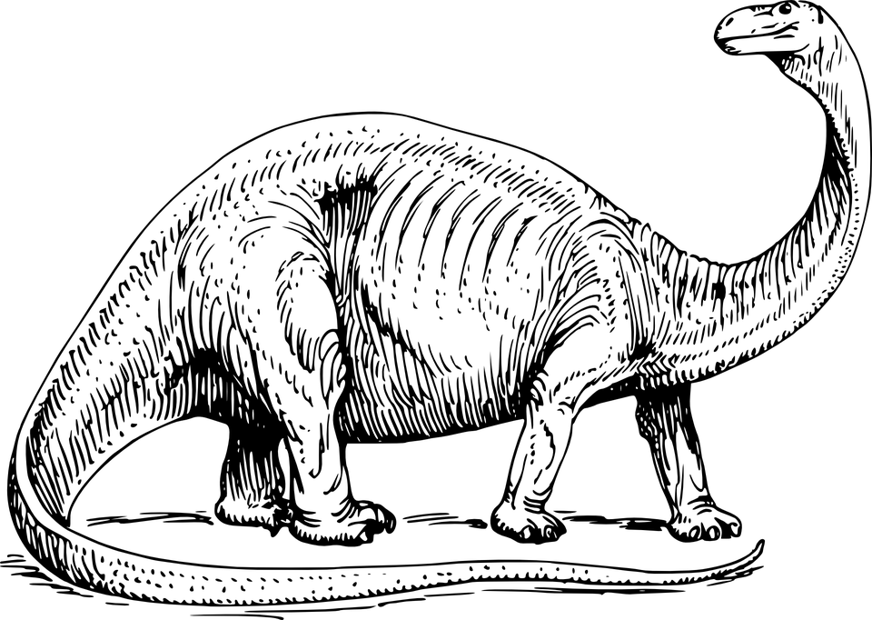

Now you may find this a touch unfair, but then whimsy isn’t for everyone. The fascination with dinosaurs can extend to searching for evidence that they were once visiting your neighbourhood. They did ours. Just below the surface, among some pine needles, Cohen found what many think was the porcelain handle of broken pottery. It still sits in his treasure chest as the remnant of a local visit. One of the first finds of a future archeologist. P.S. Should you plant it, be sure not to leave footprints and being a senior myself - remember where you put it.

**13. HEAT LIGHTNING**

As children grow up, sooner or later their imagination begins to wane. Why? I'm not really sure. I suspect they equate whimsy with childhood and want to "grow up", and shed all that is childish. As shared whimsy wanes, so does trust, displaced by independence. Sorry but true - such is the plight of mankind and the reality of parenting.

Trust while well-earned is maintained as long as we can be their guides into and around the land of whimsy. But when it is lost, and it can happen in the twinkle of an eye, it is gone forever. Well maybe not forever; they too may find it again when it is their turn to be a Panda.

Here is the moment when whimsy was lost with my boys. They were well past teddy bears. We were on a holiday, visiting a place of my childhood. A summer evening walk on a beach: the surf and breeze to our left, the dunes in the shadows and night to the right. Then a light swept across the sky, over the ocean. And then another. "Heat lightning," I exclaimed, "Let's watch."

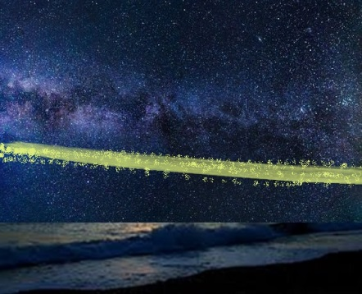

And so for the next half hour or so we lay at the foot of the dunes and watched as heat lightening flashed across the sky. In wonderment I shared my youth: the moments on the beach, the hot days, cool nights, and magic of heat lightening.

The moment was soon to end as we rose to return to our cabin. And as we did we each saw, what I for one will never forget. And they never did. There behind the dunes was a road, a point where cars were turning and their headlights sweeping across the sky.

My boys grew up a little bit that night and I aged a lot.

**14. PLACES AND PLAY**

The kitchen has always proved to be a great place for adventure – full of technology and creative moments. Consider all it’s features. There are pots and pans for drumming. Lots of water play in bowls large and small, and usually of many colours. Learning all the ingredients for pancakes is a winner: where to find them, how to mix ‘em, and all the different shapes to make.

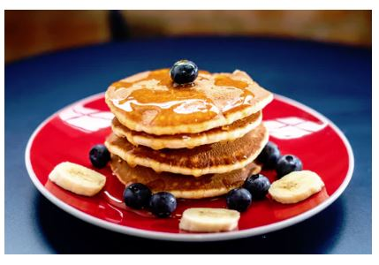

The kitchen window is a special place for watching birds, weather, and all the backyard action throughout the seasons. If the window-cill gets sunlight, it is a great place to learn about seeds and how to grow an apple tree.

Every kitchen should have a stool for getting up and watching whas’up. Better yet, is the value of a stool for extending their reach to where the cookies are kept.

I’ve used the kitchen for baking and tasting, washing and cleaning, colouring and cutting, and for just plain messing around.

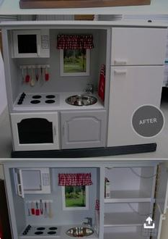

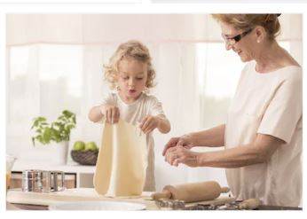

For more about messing around – the bathtub was invented for child’s play. The duckies and soap, a place for hot and cold, slipping and sliding, bubble baths too and there is so much anatomy for cleaning.



Building forts, hide and seek, and general horse play define the purpose of a couch and the more pillows the better. And always leave some space behind the couch…it can be a home away from home. A castle. A fort. Pillows can substitute for doors.

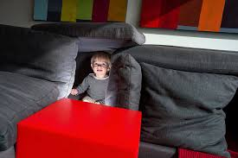

Before they are gone forever, you should find “the woods” again, a place for many fairytales and where privacy is treasured.

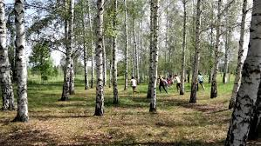

**15. PUZZLES**

I must admit some of my fondest memories with my mother were sharing the making of a puzzle. There are so many types that are age appropriate and when done, painting them with a thin mixture of flour and water can preserve them as a wall hanging. Here is the most complex puzzle Cohen and I ever attempted, it’s 3-D that when done made for a great show and tell.

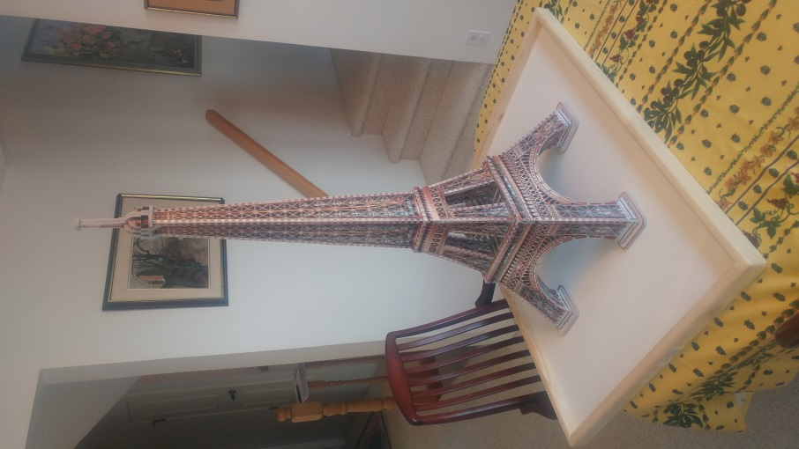

Cohen’s mesmerized about someday going to where the Eiffel Tower stands.

**16. SUSQUATCH**

These stories are more than whimsical, they are riveting. I shared them as bedtime stories. A friend in Nova Scotia says his children, now adults still recall them in detail.

Susquatch live in families alone in the forests of western Canada. They are very elusive and very big - some standing over 8-feet high, and hairy - humanlike. They are rarely seen rarely with only footprints and an occasional tuft of fir left behind.

One summer I was camping in the mountains. The evening - never to be forgotten, I was asleep in my tent curled up in my comfy sleeping bag.

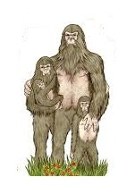It was very dark and in the middle of the night I awoke, shaken and being hauled away huddled in my sleeping bag. I was really scared and taken to a susquatch shelter. There I was dumped out of my sleeping bag in front of a family of susquatch. I was oggled at and on display for what seemed like an eternity - but was only most of an evening.

The family was comprised of: a momma, papa and their little one all having their fun with me. They laughed, poked, and rolled about. (I added much more to the episode.) Then I fell asleep, waking in the morning, In the tent just where I was taken the night before.

Most kids by this time were either sound asleep or clamouring for more.

**17. NATURAL THERAPY**

Sometimes help is unintentional and therapeutic. This one is a family favourite. The names have been changed to protect the innocent.

The little boy was adapting slowly, rarely participating...always holding back. But he clearly loved his new foster mom. He just didn't know how to express it.

One day, after school Rajesh went out of his way to sit on the couch next to his new mom. He'd done this before but never a word. This time he was clutching his paper lunch bag, that was sitting on his lap.

For the first time he spoke up, eyes down and in a soft voice "Do you want to know what I have in the bag", he asked.

She, somewhat startled, replied "Of course Rajesh, what is it?"

"It's for you," he replied and shyly handed her the bag.

She peeked in and saw what looked like a moldy brown muffin. "Probably a class project," she thought.

But not wanting to disappoint, she reached in and took a bite. And sure enough, it was awful.

Then to her surprise, Rajesh - eyes wide open, mouth agape, exclaimed, "But that's a clay ashtray!"

She smiled; reached out and took his hand - "Thank you, Rajesh. I like it." He too smiled, gave her a hug, and hasn't stopped talking since.



**18. FAVOUITES**

Colors. Numbers. Foods. Ice cream. Kids have lots of favourites - their first judgements. Whatever, the number 8 was Cohen's choice.. "Why," who knows. But he was vigilant, seeing 8's on license plates, house addresses, announcing sightings anywhere. A visit to the local Super 8 Hotel was a big time moment.

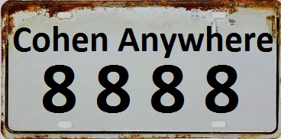





**19. SHARING**

During long car rides, I'd try to talk up a story and inquire about Cohen’s interests. One time, knowing his first love for Fiona I asked if he ever drove his play car Mercedes to Fiona's house. She lived only a block away.

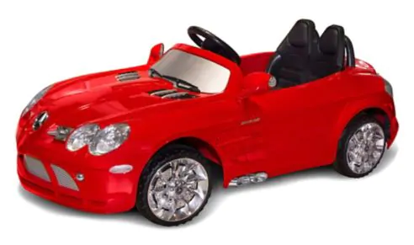

"Yes," he said, "she lives over there," pointing to her house.

"Do you ever let her drive," I asked.

"Oh no. She doesn't have a license."

I smiled. Intrigued. "Oh," I asked, "and you have one?"

He continued without hesitation explaining how he'd got a job and bought his license.

Should I worry?

**20. A LAND BEYOND THE CLOUDS**

One story is rarely enough and when children come over they want to be part of a story.  So I created a standard setting for stories. Imagine...a birthday party, and the chorus of "Pleeze Panda. A story. Me too!"

The setting was an imaginary land  "Beyond the Clouds" and over the mountains comprised of 4 settings and a ranch. Found in the north 40 were a circus and a zoo. In the west 40 there were mountains and a gold mine, cattle and bandits. The east 40 was a swampy jungle of prehistoric creatures. And the south 40 was a landing pad and spaceship to planets of the solar system.

The land Beyond the Clouds was reached by a Boeing 747 that was linked to a railway ending at a stable where we mounted our horses. Then a covered bridge and the trail to nana's ranch house and barn.

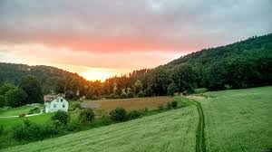

Every child in the story had a horse with a unique color and personality. There was whiteface and blackface, blue belly and pink jellybean. So many kids. So many horses.  I often had to ask for help in remembering each special mount. They always remembered.

The kids would tell me where in the land they wanted to go. Every story started with the flight to K, an adventurous journey to the ranch house to greet grandma with "Hi and Bye. We'll be back soon." And then off  to one of the quadrants.

Each story ended with a return to a worried grandma who always had pancakes ready before "Goodnight" and a sleepover.

**21. VEGETABLE LASAGNA**

I don't know for sure how she got her name, but momma's turtle went by the name "Vegetable Lasagna". She - I think, she was a she, had a special affinity for grandma, always finding her and "cuddling up" at her feet. Grandma loved turtles (and little frogs). VL was special.

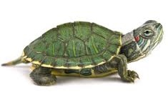

One day, before work we set her outside to  sun in the sandbox. But when we returned home after work, she was gone. A mystery. We speculated, could she have buried herself somewhere or been taken by a playful neighbor? Maybe t'was a big hawk or coyote that got her. Something needed to be done.

Panda to the rescue. He made up several notices for taping to lamp-posts throughout the neighborhood reading:

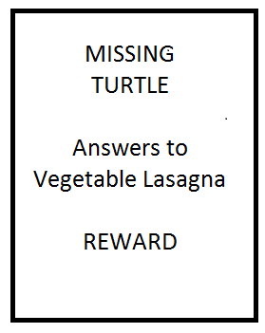

Not only did the sign get chuckles from neighbors, but the local kids formed a patrol and throughout the weekend could be heard "Here Vegetable Lasagna. Here Vegetable Lasagna."

To this day, I suspect VL was the main course for a big owl. The reward remains unclaimed.

Not The End. ("The End", Cohen has advised me, is his shortest story.)

Momma didn't take the loss of VL lightly. And so at the children's begging another turtle, slightly smaller was adopted. She - just called "Turtle", was even more affectionate. But suffered a plight worse than VL.

Momma left Panda in charge before she left for a weekend Conference. Panda was to "Look after her," as momma 8nstructed before leaving. But Panda assumed Turtle was in her aquarium. But Panda was wrong. When he went looking, he found her dried up under a couch.

What to do? What to do? Well he soon found a Reptile Rescue phone number. Indeed they had a turtle, rescued and living nearby. Panda dashed over met the family and "Bubba!" too. "Bubba" - a name fitting for a big Red Slider, but of a size that by no means could be mistaken for little "Turtle".

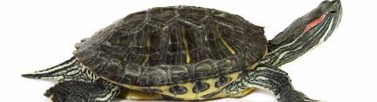

What to do? What to do? Panda, never one to surrender figured it out. Bubba was retrieved - poking his head out as if to say "good bye" to his tearful adopted family, and speedily taken to his new home. There Panda substituted the small aquarium with a somewhat larger one...well more than "somewhat". But the proportion seemed right, "Maybe she won't notice," Panda hoped.

We have a botanical garden not far away. Lotsa lily pads and a big pond. Bubba's now king of that pond, his new home. He loves it there.

Passive pets are not Panda's forte. And he sometimes doesn't listen all that well.

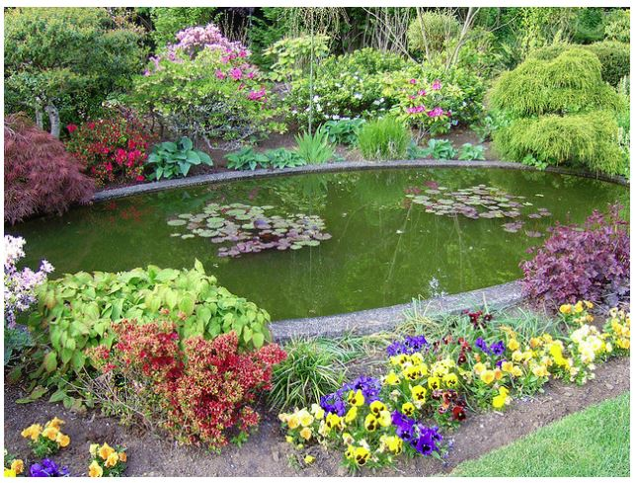

**22. SEVERAL?**

My vocabulary is often lacking, even more so when Cohen's around. His latest, with insistence was to ask, "How many is 'several'"?

I need a nap.

**23. BROTHERLY LOVE**

Sometimes momma was on her own. The car ride through the mountains was to be long. Peter would be a handful. Paul too  but Peter was concern #1. What to do? Sleep - a nap. But how? The good doctor suggested a teaspoon of cough syrup.



Good idea, but...less than an hour into the journey the chaos in the back seat was relentless. Then silence…before Paul piped up loudly with, "He's peeing on me!"

"That's it. I've had just about enough of this," she exclaimed, taking charge and pulling Peter aside.

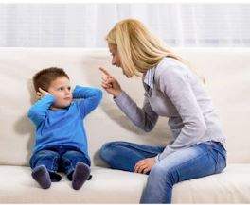

He with big eyes, and a broad smile, looked up and declared, "Mommy, I have a good attitude!"

Now how do you counter that?

**24. ALL BUSINESS**

Paul rarely crept into my bed so this event was unusual. We were visiting grandma and were sharing the same bed. It was early morning, and I recall just waking with warm rays of sun lighting our room.

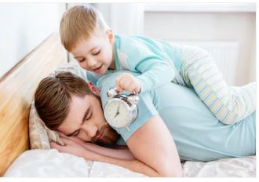

I had an odd sense that I was being watched, closely.

Sure enough, as I opened my eyes, there staring straight at me was Paul and asking, "What's on the agenda for today dad?"

**25. THE COLLECTOR**

Paul could be very curious. He had to be watched. One Saturday I brought him to the office where I intended to be quick in retrieving some documents. He was quiet, too quiet.

When I emerged from my office, there he was having crawled into the office coffee cupboard. He was pouring a large bag of sugar into a nice neat pile.

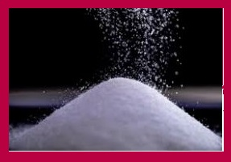

I should have known, because that Christmas Day, he'd gone to the living room and there proceeded to take every Christmas bulb within his reach and place each gently into a nice neat pile.



And then there was the time he unraveled a dozen recording tapes while in his crib. The room was a spider's web of cellulose. The tapes were within reach as we played classical music from a recorder next to his crib. His love today is heavy metal.

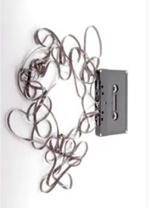****



**26. HAY STACKS**

Hay stacks trigger a child's imagination as do piles of autumn leaves and puddles after a spring rain.

We were on the way to the cottage. It was fall and farm fields were littered with hay stacks.

Paul was not more than three years old and musing in the back seat. He took us all by surprise breaking the silence with "Look at the haystacks!” And continued …

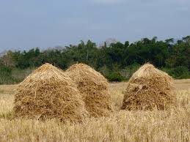

“I want to sleep in the hay with Meghan."

We shared this with no one, until now. Meghan went to Princeton and lives somewhere in the US now.

**27. SHARING COCA COLA**

Peter was only 9 and asked me for some Coca Cola. "Ask your mom," was my reply. "But dad, Coca Cola invented a new breakfast drink in Japan and it his going to do really well."

I realized he was inquiring about ownership and so I explained what was stock and bought him one share of Coca Cola, mounted over his bed.



A few weeks later he initiated a discussion about Goodyear. He was apparently reading quotes in the newspaper following Coke and noted  "All the stocks are goi g down except this one." We bought five shares of Goodyear. Well with little coaching and a few windfalls, he was able to pay for his college tuition.



Today he has his BCom and financial management certificate and is President and CEO of a market exempt investment firm.



**28. CARING FOR KIDS**

Paul like his grandpa always had a love for kids and teaching. Even at the cottage, he reached out with a passion to share his insights with the neighbor boy, Alex. Sometimes he just sat in a field with Alex searching for four-leaf clover, other times searching for edible mushrooms. But his real joy was in teaching him words and sharing ideas.

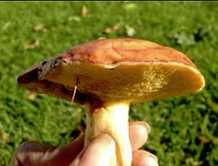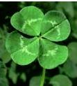

.

And as a young man going to university, he found his way from medicine, to psychology and finally education. But there was a rebel in him, a passion. He wanted to teach, but not as a member of a union, and not in a large setting.

OMG what to do?

As luck would have it, a local start-up tutoring agency needed a tutor. Paul fit well. Very well. So much so, that after his first year the owner offered him the job of General Manager to operate the agency.



Instead, he bought the agency. A year later Christie, his wife, joined him and they together grew the enterprise into a very successful, often awarded tutoring practice.

Who'da guessed?

**29. FINDING THE LIGHT**

When and how to move out can be tricky. Peter was out last and made his way with nary a hiccup. Paul had to fight for freedom.

We were in the family room, enjoying the glow of a fireplace. Comfy together with pointless conversation, when Paul in his 1st year of university stood up and declared, "I am moving out!"

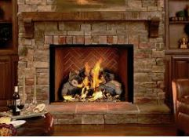

That did not go down well. And his mother let him know it was "Unacceptable!" But he was ready and relentless. The storm and it’s fury was upon us and it raged.

Though the fire was now out, the sparks continued – like artillery in the night. Then as abruptly as it had started - silence. Nothing. I could sense a pending explosion. "Whoever speaks next," I thought, "Will trigger a disaster!"

Where it came from I'll never know, but I entered the fray.. "Paul, all change doesn't have to come through revolution. Some change can come through evolution," I said.

Then there was light. His mom spoke up with "Why don't we work out a plan" and that was that. Peace was restored.

Later, she turned to me and asked "Where did you come up with that?" I had no idea, but mused that I did take some history and political science in college.

Today I suspect that the real driver was my love for both of them, and my adolescent practice in helping my parents resolve their periodic conflicts.

**30. INNOCENCE**

Kittens. Puppies. Babies always catch a young child's attention. They "ooh and ahh" and seem to know without coaching the gift of a gentle touch.

Great grandma was special. Though she was bedridden, she was always warm and comfy when visited. Cohen would sit quietly, hand in her hand as if mesmerized by the gentle moments with her. Not stirring. Never bored. I never really could comprehend his patience.

When great gradma passed away, we were concerned how to explain her being away. But he seemed to understand that she was gone, elsewhere.

When we cleared out and vacated her house, he wanted to check out the house just once more. I followed him in and he asked me to take him to the basement. "Maybe she's hiding in there", he explained.

Some months later, he learned he'd be flying to Mexico for a holiday. "Maybe we'll see grandma on a cloud," he asked?



Shear innocence.

**31. YOUR TURN**

I seem to have come to end of my recollections. The harder I try, the more elusive the memories become. Best I give you a turn. Maybe you have some memories and moments to share.

___________________________________________________________________________________________________________________________________________________________________________________________________________________________________________________________________________________________________________________________________________________________________________________________________________________________________________________________________________________________________________________________________________________________________________________________________________________________

___________________________________________________________________

**PROLOGUE**

Our children are grown up now. And as for our grandchildren, they each still trust Panda. But not for long. As for me, I'll always relish the days when they were very young.