ABctech #127 05Oct18 Economic Diversification Fall 18
Economic diversification and the effectiveness of Alberta's innovation ecosystem dip
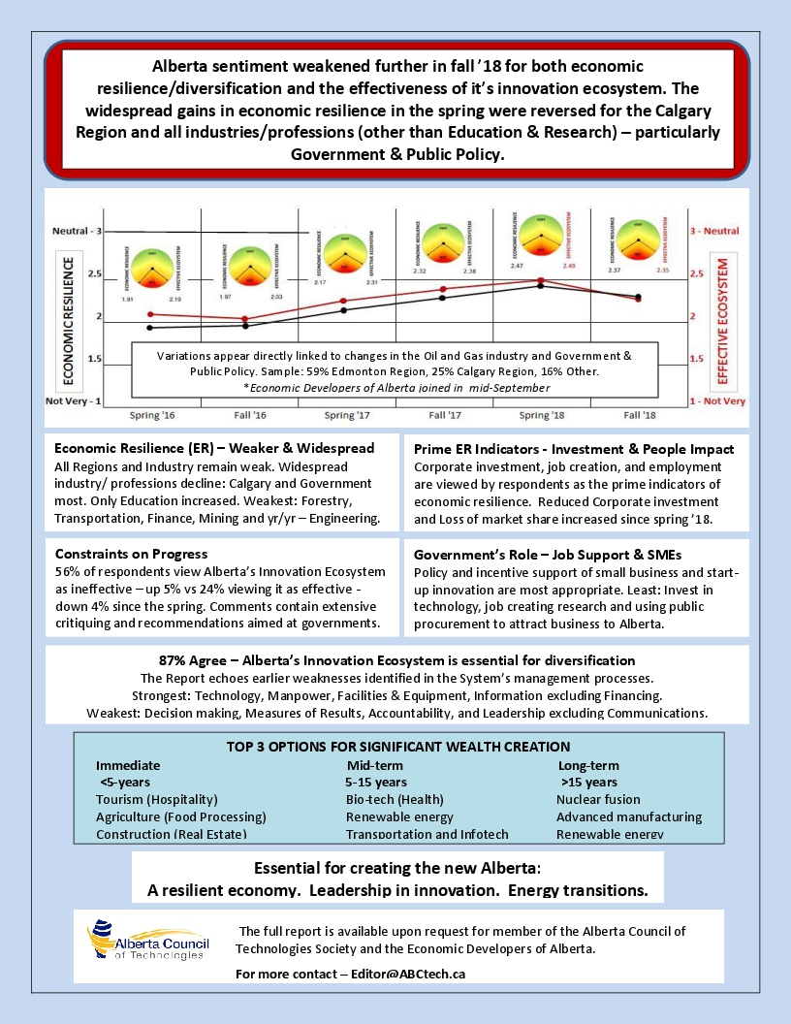
Sentiment in the resilience of Alberta's economy has dipped for the 1st time since 2015. The decline may be related to pipeline uncertainties and further corporate constraint on spending.
Sentiment in the effectiveness of Alberta's innovation ecosystem - core to diversifying the economy, also dipped. And for the 1st time is now below that of resilience. FOR MORE
The Economic Developers Alberta has joined the project - adding it's network and advisory input to conduct of the semi-annual survey. FOR MORE

RISING STARS Symposium – Personalized Healthcare Innovations
Alexander Suen has finalized design of our October 23rd RISING STARS Symposium - Personalized Healthcare. This exciting, insightful event is featuring workshops, a networking reception, and after dinner unveiling of 4 selected early-stage companies introducing advanced data technologies for personalizing healthcare. Register HERE

Ontario Council of Technologies Society
Jac van Beek and a select team in Ontario are exploring formation of an ABCtech counterpart. "Our issues are similar. The challenge to establish an effective innovation evosystem are enormous," says Jac van Beek. The Ontario Council of Technologies Society will be educating the public about emerging technologies and their impact and the development of essential technology networks. We are grateful to ABCtech as our partner in this collaborative enterprise." FOR MORE

TechInvest - Technology Investment
Don Diduck was commissioned by ABCtech to establish a technology investment fund and associated credit union. ABCtech is completing due diligence on an MOA received from TechInvest spelling out mutual expectations and options for introducing TechInvest to prospective partners and investors. FOR MORE

Creating a Western Canada Hemp Industry
Jesse Hahn is helping Agriculture Food Council to capitalize on input received at it's co-hosted industry Conference for creating a western Canada hemp industry. Preparations are underway including strategic planning this January and a followup conference in the spring. FOR MORE

Engaging Canada's Youth - The Future of Work
Phil Davidson has been appointed to lead our 2019 project Engaging Youth - the future of work, extending the consultation nationally adding post-secondary students. 2018 REPORT HERE

Traceability - Securing Supply Chains
ABCtech is very interested in the application of data, sensors, blockchain and a host of related technologies to supply chain management for addressing fraud and corruption, product losses and accountability. Ingeni has shared it's insights about how traceability is transforming supply chain management. Read the article now

Public Procurement - is it broken?
Discussion is underway to further explore the findings and recommendations contained in our spring survey and report. Read report here.

We have a Vision - a more resilient Alberta economy ... and a Mission: 1. Educate the public about emerging technologies and their impact, 2. Develop the technology networks essential for innovation, and 3. Contribute to development of Alberta's innovation ecosystem. JOIN ABCtech NOW
We are volunteers 21,000 strong, relying on members and referrals, services and events, for resourcing projects. Our Technology Industry Alliance is comprised of NGOs committed to working together for results. LEARN MORE ABOUT OUR ALLIANCES

EVENTS - Schedule
October 23rd Edmonton. RISING STARS - personalized healthcare symposium featuring four worthy Regional start-ups, a networking reception, buffet dinner, and 4 pre-reception, simultaneous 1.5-hr. workshops. Register HERE
FOR MORE - visit ABCtech.ca/events to view all events.
Submit your event here

