ABCtech #48 Creating the New Alberta Economic Resilience – Fall 2015

Creating the New Alberta!
Report HERE reveals options for addressing Alberta's wide-spread decrease in economic resilience and weak SME ecosystem
 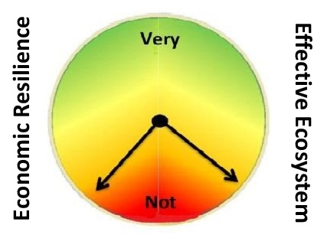
ALBERTA’S CURRENT REALITY

Widespread Resilience Decrease | Jobs/People Impact Severe
Edmonton Region decreased 19%, now ...  On par with Calgary. Most industries decreased  Only Legal Services and Tourism escaped | Decreased corporate investment  Increased unemployment and layoffs  Decreased job creation
Constraints on Recovery | Limited Government Role
67% view the Ecosystem for SMEs as ineffective  Banks and VCs are too risk averse to help  Market access, debt and government ideology | Policy support for SMEs and entrepreneurs  Invest in research before projects or techcom  Negotiate trade agreements
Industries Most Vulnerable | Industries Least Vulnerable
Infotech (Analytics) and BioTech (Health)  Research (Education)  Forestry (Wood Products) | Legal (Security)  Human Resources (Development)  Tourism (Entertainment & Hospitality)
TOP 3 OPTIONS CITED FOR SIGNIFICANT WEALTH CREATION
Immediate | Mid-term | Long term
< 5-years  Tourism (Hospitality)  Agriculture (Food Processing)  Construction (Real Estate) | 5-15 years  BioTech (Health)  Renewable energy  Transportation and Infotech | > 15 years  Nuclear energy including -  advanced manufacturing  Renewable energy
Essential for Creating the new Alberta! A resilient economy, Leadership in innovation, and Energy transitions

Join us in Red Deer, November 26th - our all-industry Convention for addressing
what can be done to advance recovery and improve Alberta's economic resilience
 *Full Report at http://www.ABCtech.ca

