Creating the New Alberta - Vision & Leadership

Attracting Big Ideas - The Time is NOW!


What technologies can help revitalize Alberta's economy?

A Convention like none other …. most timely for inspiring initiative and the convergence of BIG IDEAS by Alberta’s industries and professions contributing to economic recovery and long-term diversification. Share yours. What Can be done. What is being done. The time is Now for Innovation. Convention features:

KEYNOTES - Insightful and inspiring Opening, Luncheon, and Closing
BIG IDEAS - Presented by Alberta industries and professions
RECOGNITION - ABCtech’s 2nd Annual Innovation Award and top 3 BIG IDEA presentations
CONVERGENCE - Panels with Q&A presenting VERY BIG IDEAS for expediting change
ACTION - An engaging Plenary session for Setting Direction and Taking Action
CONNECTING – Wrap-up Networking Reception. Meeting Alberta leaders and visionaries.

Date, time and location | Saturday, November 26th  9:00am to 6:00 pm  Cenovus Learning Centre at Red Deer College MAP HERE
Highlights about the BIG IDEAS Convention
Sharing of BIG IDEAS and the birthing VERY BIG IDEAS for aiding Alberta's economic recovery and long-term diversification. Bring yours - audience engagement is a prime expectation.
SCHEDULE
8:00 am Registration Desk opens – badges and program handout
9:00 Opening Keynote – “Vison & Leadership
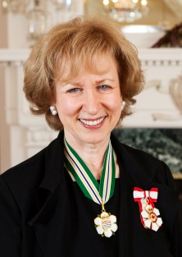 | Rt. Hon. Kim Campbell. PC, CC, OBC, QC. Founding Principal, Peter Lougheed Leadership College, University of Alberta. Served as the 19th and first female Prime Minister of Canada. As a Member of Parliament, she held cabinet port-folios in Indian Affairs, Justice and Attorney General, National Defense, and Veterans Affairs. Ms. Campbell has served as the Canadian Consul General in Los Angeles, taught at the Harvard Kennedy School, and chaired the Council of Women World Leaders. She is a founding member and Secretary General of the Club of Madrid, an international organization of former presidents and prime ministers. In August 2016, Prime Minister Justin Trudeau appointed Ms. Campbell as the Chairperson for the Independent Advisory Board for Supreme Court of Canada Judicial Appointments."
9:30 am Big idea Attendees will have 3 votes for choosing the top 3 BIG IDEAS contributing to
Presentations Alberta’s economic recovery and long-term diversification from among several
PPT presentations by Alberta industries and professions:

Agriculture & Food Processing Forestry & Wood Products
Transportation & Logistics Construction & Real Estate
Health & BioTech Volunteers & NGOs
Fintech & Investments Mining & Mineral Processing
BREAK
Tourism & Entertainment Communications & Marketing
InfoTech & Analytics Manufacturing & Export
Environment & CleanTech Alternative Energies
BREAK
Engineering & Design Education & Creativity
Legal & Security Management & Strategy
Human Resources & Development Finance & Accounting

12:30 Buffet Luncheon

Keynote – “Energy Transitions in Alberta”
 | Donna Kennedy-Glans Lawyer, businesswoman, and former Associate Minister of Electricity and Renewable Energy (Alberta). Spent 30 years in the energy sector in Calgary as a negotiator for TransCanada in the 1980s; was the first female Vice-President at Nexen, Inc.; and from 2002 to 2102, served as an independent consultant advising global energy operators on how to best manage non-technical risks. Author of Corporate Integrity: A Toolkit for Managing beyond Compliance, Unveiling the Breath: One Woman’s Journey into Understanding Islam and Gender Equality. In 2007, received a Woman of Vision award; the Calgary Herald named her a ‘Compelling Calgarian’ in 2010; she received the Queen’s Diamond Jubilee Medal in 2012; she was named one of “Alberta’s 50 Most Influential People” 2014 by Alberta Venture in 2014; and one of “Canada’s 50 Most Powerful Business People” by Canadian Business in 2014.

Recognition |  | Announcing and awarding the top 3 BIG IDEA presentations and presentation of ABCtech's 2nd Annual Innovation Award
2:00 pm Convergence Panels and Q&A | Three moderated panels portraying VERY BIG IDEAS, selected for expediting change as the convergence of opportunities with an audience Q&A
 |  |  | “Very Big Ideas” - Panel Moderator.  Heather Douglas. President, Strategic Public Affairs Ltd. and President, CEO Platinum Roundtable. Recognized for Excellence in Communications Launched Strategic Public Affairs Ltd. In 1997 and in 2014 CEO Platinum Roundtable Ltd. The executive roundtables give members a change to explore global trends which will impact their companies and the way they do business. Ms. Douglas was named Business Woman of the Year in 2008 and was nominated as one of Canada’s most original thinkers in 2008, 2009, 2010. She has won numerous awards for her writing, public affairs programs and international government relations strategies.
  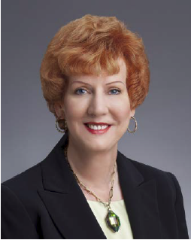
3:30 pm  Plenary Session | Roundtable discussions for deriving recommendations, concluding with an overview for setting direction and taking action
4:45 pm  Networking  Reception |     Sumptuous networking reception and draw prizes. Meeting Alberta's leaders and visionaries. Co-Sponsors
6:00 pm Closing Keynote – “Growing Together”
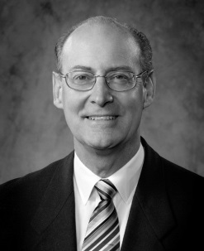 | Perry Kinkaide. MSc, PhD, CMC. Retired as Managing Partner of KPMG Consulting and has since remained active as President of KEI Enterprises – investor, advisor and director for several public and private organizations and the founder and CEO of the Alberta Council of Technologies Society - with over 13,000 followers. ABCtech embodies Perry’s continuing interest in the socio-economics of emerging technologies. He received his PhD in Brain Research from the University of Alberta in 1972, served as Assistant Deputy Minister with the Alberta Government through 1987, and Managing Partner of KPMG Consulting through 2001. He was recognized in 2007 by Alberta Venture magazine as one of the 50 "most influential" Albertans.
Registration & Convention Sponsorship
Registration | Click HERE to Register "Creating the new Alberta!" November 26th, 2016  Member discounts 20% apply automatically when registering. Not sure you are a Member? Contact info@ABCtech.ca or phone 1(866)241-7535  To become a Member of the Alberta Council of Technologies Society - HERE
Sponsorship &  Marketing | For Convention Sponsorship and Marketing opportunities please contact info@ABCtech.ca or phone TF 1(866)241-7535 Local (780)990-5874

