

Resilience of Alberta’s Economy
AND
Measuring the Effectiveness of
Innovation Ecosystems

The Alberta Council of Technologies conducts a spring and fall survey of its followers for assessing the "Resilience of Alberta's Economy" AND evaluating the "Effectiveness of Alberta's Innovation Ecosystem". The following Report contains the summary results of the Surveys conducted in March 2017.

Prepared by:
The Alberta Council of Technologies Society
April 2017

Monitoring Alberta's Economic Diversification - March 2017

Monitoring Alberta's Economic Diversification - March 2017

Monitoring Alberta's Economic Diversification - March 2017
Monitoring Alberta’s Economic Diversification – March 2017
The Alberta Council of Technologies is "Creating the new Alberta!' through our network of contacts sharing an interest in emerging technologies and their commercialization. You can help! The following survey is repeated each September and March for monitoring and benchmarking Alberta's economic diversification.

Survey results will be available next month - published through QuikTech Notes and posted at www.ABCtech.ca. Questions and comments should be directed to editor@ABCtech.ca

First, about ALBERTA. We view diversification as the primary means of making Alberta's economy more resilient, that is, less vulnerable and more able to recover from economic shocks.
On a scale from 1 = Not Very Resilient to 5 = Very Resilient, please rate how you view the diversity of Alberta’s economy

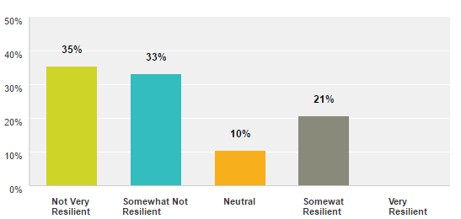  1 2 3 4 5 |   Cloud Summary of Comments  Regional Breakdown (Resilience: 5 = Very, 1 = Not)  Spring ‘17 Fall’16 Spring’16  Province Overall 2.17 1.97 1.91  Edmonton Region 2.07 1.98 1.89  Calgary Region 2.40 1.95 1.92  Other 2.25 1.97 1.96
Observation – The overall sentiment that the Alberta economy is not resilient continues, though somewhat more positive since 2016
- 2/3rds (68%) of respondents view the economy as not resilient – comparable to 2016 with 68% in the fall and 78% in the spring
- 1/5th (21%) view the Alberta economy as economically resilient – up considerably from 2016 and the fall (6%) and spring (5%)
- On a scale from 1 to 5, with 1 being Not Very Resilient, the overall average is 2.17 up somewhat from 2016 and 1.97 in the fall and 1.91 in the spring
- While overall sentiment remains negative, all Regions are showing some signs of an increasing sentiment of economic resilience with the Edmonton Region now lagging the rest of the Alberta in the recovery.
Comments – Alberta’s economy remains overly-dependent on the oil and gas industry
- No growth or long-term prospects. (1 – Calgary)
- Problems will not go away until this government does. (1 – Calgary)
2 Page
- Too much job loss and business closures when oil prices decline. (1 – Edmonton)
- Alberta is still stuck on oil, no diversification, hence no progress. "Live with the "oil" die with "oil" alone! (1 – Edmonton)
- The Alberta economy is showing signs of improvement, but is still shaky. (2 – Edmonton)
- When Oil & Gas is down, just follow the news. Higher percentage directed towards that industry. That's an indication of its importance and speaks to the lack of resilience. (2 – Calgary)
- Not as innovative as we think; too much innovation is dedicated to improving oil sands extraction and going forward few investors are looking at the oil sands as a long-term play. (2 – Edmonton)
- Still depends too much on extraction of natural resources and their volatile prices. (2 – Edmonton)
- So many more people are thinking now about our future populations than were doing this 2 years ago. Mr Trump may be an early herald. (3 - Edmonton)
- On a tipping point with oil, we have the brain power and tech to change but no investor courage to change. (4 - Other)

Next, is to better understand what factors underlie the assessment of economic resilience.
What factor(s) are the most sensitive measures(s) of whether Alberta’s economy is or is not resilient?
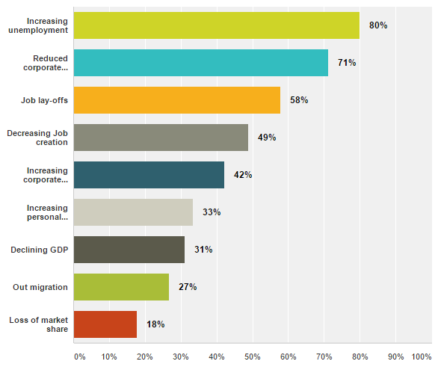 |   Cloud Summary of Comments

Increasing Unemployment and Reduced Corporate Investment are most frequently and consistently cited as the most sensitive measures of Alberta’s economic resilience. Both are up since the fall and spring of 2016
- The most sensitive (top 3) measures of resilience remain: Increasing unemployment (80%, up from 65% and 65% in the fall and spring in 2016), Reduced corporate investment (71%, up from 63% and 66% in 2016) and Job layoffs (58% v 58% and 55%),
- Less sensitive measures remain comparable with the fall of 2016: Decreasing job creation (49% v 56% and 56%), Increasing bankruptcies: corporate (42%, up since 2016 - 33% and 30%) and personal (33% v 33% and 29%)
- Least sensitive are Declining GDP (31%, down since 2016 - 52% and 46%), Out migration (27% v 34%) and Loss of market share (18% v 27% and 24%).
Comments –
- This government is operating on ideology instead of economics. (1 – Calgary)
- Too many regulations are strangling the economy. (1 – Edmonton)
- Increasing crime rates (1 – Edmonton)
- It is a natural economic cycle (1 – Edmonton)
- Lack of Government interest in economy & business diversification (1 – Edmonton)
- The way employment is calculated has changed. There are many people on contract that do not show up on EI figures or in the census. The total "shock" to the Alberta and Canadian economy is in need of revision. (1 – Edmonton)
- The unbalanced viewpoint of the current industry and how we got to where we are. (2 – Calgary)
- An unfriendly, predictable business investment environment. (2 – Other)
- Decreased/ increased company creation/registration. (3 – Edmonton)
- Government agenda not in touch with resource sector. It is top down not bottom up approach. (4 – Other)

In the next section we investigate the economic resilience of Alberta’s various industries.
1 = Not …. 5 = Very
Resiliency Index
Spring ’17 v Fall ‘16
2.86 | +0.59
2.22 | +0.21
2.31 | +0.37
2.60 | +0.60
2.00 | -0.02
2.08 | +0.09
2.15 | +0.26
2.46 | +0.43
2.33 | +0.38
2.58 | +0.39
2.64 | +0.41
1.90 | -0.01
2.60 | +0.49
2.67 | +0.70
2.17 | -0.09
1.80 | -0.42
3.00 | +0.85
2.00
3.00 | +0.70
2.50 | +0.38

What 5 industries are of most interest to you?
