ABCtech #161 29FEB16 Improving the Entrepreneurial Ecosystem
Improving the Entrepreneurial Ecosystem
Survival of the fittest requires intelligence systems that enable entrepreneurs to learn faster, react quicker and find resources more easily. The “Cloud” technology evolution is enabling us to do this both individually and collectively to understand and improve the entrepreneurial ecosystem. But we need to measure the right data and put the systems in place to do so.
Cloud accounting systems like Xero and Quicken already enable us to measure the financial performance of business communities as accounts can be aggregated to provide collective financial data. Financials, however, measure ‘what has happened’ rather than ‘what needs to happen’. They measure performance rather than the health or capabilities, skills and practices that deliver performance.
McKinsey executives Keller and Price in their book “Beyond Performance” conclude that if you focus on Health as well as Performance, you have a 2.2 times better chance of being in the top third of businesses performers.
So how do we harvest Health Data to understand and improve our business communities? A number of Business Accelerators have already started doing this. Spark Ann Arbor, Michigan helps entrepreneurs understand what they need to do and captures this understanding to help the community as a whole. . It is a “knowledge exchange” where they provide diagnostic tools for businesses and capture the responses to help the broader community.
To understand this take a business fitness test at www.virtualbusinessadvisor.com and look at the automatic feedback report that offers benchmarking and links to valuable on line resources.
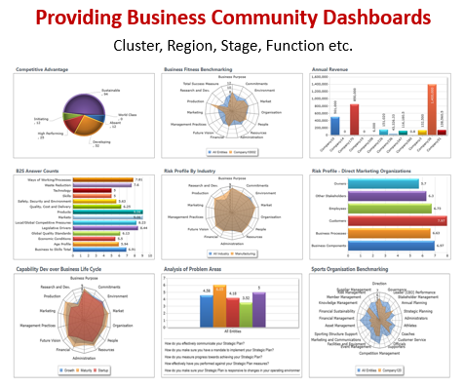
In Australia, accelerators like the Adelaide Business Hub and the Darwin Business Enterprise centre have begun to build up sizable databases enabling the understanding of capability gaps, skills and resource needs from start up through to growth and expansion. “Get enough of them doing this and you start to get a valuable picture of the whole country and its regions.” says John Todd Chairman of the Australian Business Enterprise Centre (network of some 80 accelerators).
The LA network of Small Business Development Centres has taken this further into understanding the skills and capabilities needed for export. See www.virtualinternationaladvisor.com. They can track business health all the way from idea to export.
We are coming to an age where communal intelligence is possible across the ecosystem, enabling accelerated understanding and corrective action. Business communities that understand their health and fitness must have a greater chance of improving their performance.

